**MKTG 1205 Week 9**

Activity 1: Sales Promotion

**Task:**

Propose supermarket/ shopping mall sales promotion tools to help the seller/ product in both **short-term sales** and **long-term brand preference** with its target segments. What benefit will you give to your customers to secure positive outcomes.

**Product Information:** 60,000₫ Pump 200ml

**Lifebuoy Hand Wash** makes hand washing quicker and more effective than ever before! With our Activ Naturol Shield formula, Lifebuoy Hand Wash gives 99.9% germ protection in just 10 seconds. Lifebuoy is the world's # 1 Selling Germ Protection Soap. Accept nothing less than 99.9% germ protection. The Lifebuoy range is tailored to your family's needs, from extra moisture to energizing scents.

***Total 10 Germ Protection*** contains our patented ingredient, Activ Naturol Shield, ensuring your hands are clean and protected against germs. ***Mild Care*** with milk is for sensitive skin which demands a balance between protection and care. The refreshing essence of ***Cool Fresh*** keeps your hands feeling cool and fresh throughout the day. ***Kitchen Fresh*** takes care of grease, dirt and odours picked up in the kitchen when cooking and cleaning are difficult to remove and are a breeding ground for infection-causing germs, with natural lemon fruit goodness to keep you feeling fresh and cleans hands whilst caring for your skin.

Lifebuoy has supported the Vietnam M­­inistry of Health in fighting against Flu & Hand-Foot-Mouth pandemic by spreading the habit washing hands with soap to fight germs.

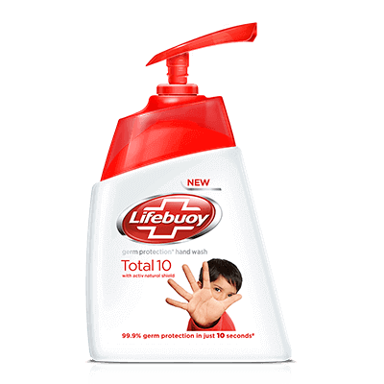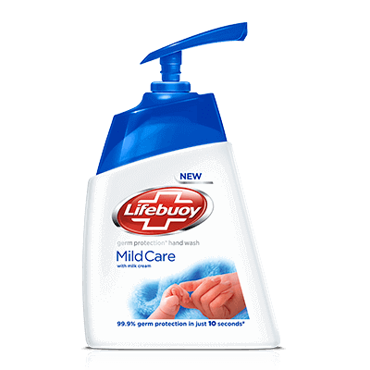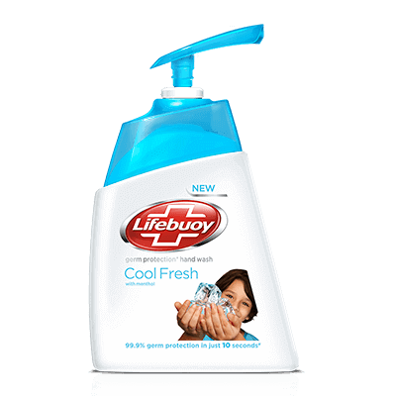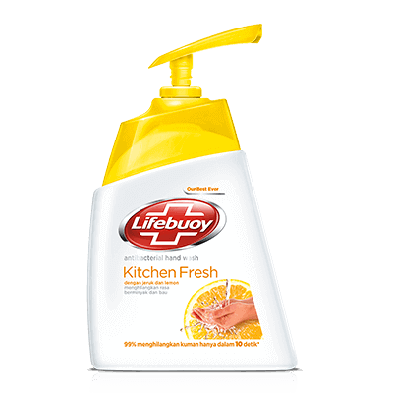

|  |  |  |  |  |  |  |
| --- | --- | --- | --- | --- | --- | --- |
| **Segment** | **Profile** | **Needs** | **Market Share**  **%** | **Type Sales Promotion** | **Period of Promotion** | **Price/ Value Benefit to Customer** |
| We are family | Families with young children. Head of the family is 30 years up, low to middle spending, educated and is working rank and file or middle management job. | Physiological and safety needs. | 50% | -Price pack  -Demonstration with Games + Free Gift, Advertising Special (towel with logo) | -3 Weeks or until supply lasts  -Sat/ Sun peak hours | -Buy 4 for 220,000vnd  -Education, how to wash hands properly, free gift for children to remind them to wash hands |
| Just the two of us | Married or co-habiting adults aged 24 years up, middle to high spending, educated, first time job holders or start-up entrepreneurs. | Love/belonging and self-actualization needs. | 20% |  |  |  |
| Crazy Cat Lady | Senior citizens, retired, living with family or by themselves with pets, low to middle spending, dependent on family’s/ government pension. | Physiological, safety and love/belonging needs. | 20% |  |  |  |
| #yolo | Young Adults, studying, living with parents or with guardians (not originally from Saigon), middle to low spending, may have a part-time job to supplement family support. | Esteem and self-actualization needs. | 10% |  |  |  |